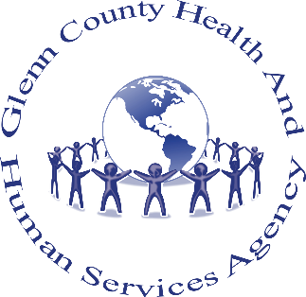
Resources for Parents During COVID-19

- “Action for Healthy Kids”
https://www.actionforhealthykids.org/covid-19-and-at-home-resources/
Content: COVID-19 at-home resources to help parents & educators keep kids active & healthy while schools are closed.
- “Child Mind Institute”
https://childmind.org/coping-during-covid-19-resources-for-parents/
Content: Help for families during COVID-19 (daily tips for parents during COVID-19 crisis, Autism & Coronavirus, managing anxiety, discipline & behavior, dealing with loss, supporting kids & teenagers during Coronavirus, ADHD support & structure during C19, mindfulness, self-care, Facebook Live events)
- “Prevent Child Abuse, America”
https://preventchildabuse.org/coronavirus-resources/
Content: Coronavirus resources & tips for parents, children & others (staying connected, family engagement, managing stress & anxiety, includes extensive list of other related resources)
- “Panorama Education”
https://www.panoramaed.com/blog/sel-resources-for-educators-school-communities-and-parents-related-to-covid-19
Content: Social Emotional Learning (SEL) & self-care resources for educators, schools & parents related to COVID-19

- “CDC: Centers for Disease Control & Prevention”
https://www.cdc.gov/coronavirus/2019-ncov/daily-life-coping/managing-stress-anxiety.html
Content: Dealing with stress of the outbreak for parents, teachers, and community

- “WRAP: Wellness Recovery Action Plan”
https://mentalhealthrecovery.com
Content: WRAP resources & tips during COVID-19
- “Mindwise Innovations: SOS Signs of Suicide Team”
https://sossignsofsuicide.org/user/login
Content: Using the ACT (acknowledge, care, tell) steps to assist those with mental health conditions or suicidal ideation
- “Each Mind Matters, a California Mental Health Initiative”
https://www.eachmindmatters.org
Content: Resources for those dealing with abuse during stay-at-home order, social distancing in multi-generational homes, support during stressful time.
- “Sana Mente”
https://www.sanamente.org
SanaMente es el Movimiento de Salud Mental

Glenn County Crisis Welcoming Lines
Transition Age Youth Center: (530) 865-1622
Peer support for youth (13-25) & parents of youth
Harmony House Adult drop-in center: (530) 865-6725 - Peer support for adults
Glenn County Crisis Line (24/7)
1-800-507-3530
